**Title Of Project**

**T.N.B. College**

**Table of Contents**

**Title Page Number**

1. **Certificate**
2. **Acknowledgement**
3. **Introduction to T.N.B. College**

* **Project Overview**
* **Project Description**
* **Objectives**

1. **Project Code and Screen Layout**
2. **Testing and Future works**
3. **Conclusion**

**PREFACE**

**Effective management of projects is vital for the development of economy because development itself is the effect of series of successful managed projects. This makes project management extremely important problem area for developing economy such as ours. Unfortunately many projects experience schedule slippage and cost overruns due to variety of reasons. To remedy the situation, a project has to be meticulously planned, effectively implemented and professionally managed to achieve the objective of the time, cost and performance**

**. Thus we see the computer becoming necessity in the day to day life. The use of computer also involves the feeling of healthy competition with the organization receiving much attention these days. Almost everyday uses of paper carry advertisements asking for project managers. The scenario was not so bright a few years back. For that matter even today though lots of seminars are held on project management, name of the universities in India offer any course to students to formally qualify as project managers. Thus, while there is very little supply. This has created all sorts of problems. Project management, unfortunately, is not but project manager practice, our attempts to demonstrate how project management, as it is concerned, can be put into practice.**

**Acknowledgement**

**The goal was fixed , the moves were calculated and I moved full of enthusiasm, figurant keen interested there were time , when it proved to be on uphill task , the goal seeming beyond my reach. But as the work progressed my determination and will power grow stronger and the completion of this work further confirmed my belief that, “where there is a will there is a way”.**

**I am thankful to my guide Dr. Rakesh Kr. Pandey and Dr. Anand Kr. Pandey for his constant encouragement and support to complete the project. He motivated me through his personal and his “never say die” spirit.**

**I specially would like to express my gratitude and debtless to my friends someway or other and been linked with the project from the one.**

**I am also grateful to project lab for providing conductive environment.**

**I would also thank my parents for supporting me in this Project work.**

**PROJECT OVERVIEW**

**The main objective of T.N.B. College management system is to automate all functionalities of a college or university. Using this system you can manage all college management work like admission, fees submission, time table management and result declaration. Using this college management system you can view or update data and information about students and staff easily. This system helps in managing the activity like student admission, student registration, fees submission. Admin can also retrieve information of employee student.**

**The T.N.B. COLLEGE MANAGEMENT SYSTEM can be used to store student information like attendance, fees, and student result etc. admin can create report regarding any student any time using this system. Using this system you can register new student and their course details. You can submit students fees and can check fees details anytime. You can create exam result and submit in this system. Student can check their result online by logging to the system. You can also add new employee in the system and can check details of the employee easily. Student can also check course detail online from this system.**

**Using this system you can manage all information of all aspects of a college, its students, faculties, Departments, marks and other curricular activities. College management system provides the easiest way to manage all functionalities of a college. This system facilitates colleges to maintain the functionality related to college employees and their students.**

**T.N.B. College Management System can store and manage all data of   the various departments of a college like Administration, Attendance, Staff details etc. using this system user can retrieve any information related to student, teacher and fees. Using this system teacher can check student attendance anytime. This system also help teacher to announce the result. College administration can also manage college work easily. Admin can check leave, salary and other details of teacher any time. They can also create time table of classes from this system. The Library module is used for the data process of library and book accessing for students and staffs.**

**Admin can also generate following reports from this system like**

**Student Report**

**Course Detail Report**

**Fee Detail Report**

**Generate Feedback**

**EXISTING SYSTEM:**

**In the existing system all the works are done manually. Students have to fill up admission form on paper and all the records are maintained on paper file. In this system it is very difficult to find any information.  And it is very difficult to maintain the fees and accounting reports of college in proper way.**

***Objectives***

**The Main objective of T.N.B. College management system for the employee is they can create any kind of certificate easily using this system. They can easily retrieve all information related to student and employee. Admin has all the Collective records of students of all the branches. Admin can check all the records of employees of all departments anytime. This system gives easy approach to find the detail information for any student/employee. Using this college management system it is very easy to handle all functionality of college. This system is beneficial for both students and employees as they can get all previous or current information when they need. This system is also helpful to maintain the students record like admission record, fees record, exam result records.**

**T.N.B. College management system can help to get all or a particular student attendance information.  Also it can help to maintain the fees and accounting reports of college in proper way. This system also helps to generate mark sheets of current year.**

***Main Page***

***<!DOCTYPE html>***

***<html>***

***<head>***

***<title>T.N.B College</title>***

***<link rel="stylesheet" type="text/css" href="style.css">***

***<link rel="stylesheet" type="text/css" href="https://stackpath.bootstrapcdn.com/font-awesome/4.7.0/css/font-awesome.min.css">***

***<link rel="stylesheet" href="https://cdnjs.cloudflare.com/ajax/libs/font-awesome/4.7.0/css/font-awesome.min.css">***

***</head>***

***<body>***

***<div class="Header">***

***<img src="picture/logo1.png" class="logo1">***

***<img src="picture/head.jpg" class="headi">***

***<div class="search">***

***<input type="text" placeholder="Search......" name="search-text-input" class="search-text">***

***<i class="fa fa-search"></i>***

***</div></div>***

***<div class="Nav-menu">***

***<center>***

***<ul>***

***<li ><a href="#" class="active"><i class="fa fa-home"></i>Home</a></li>***

***<li><a href="About.html" target="Content1"><i class="fa fa-users"></i>About Us</a></li>***

***<li><a href="#"><i class="fa fa-clone"></i>Addmission</a>***

***<div class="sub-menu-1">***

***<ul>***

***<li><a href="Addmission.html" target="Content1">B.C.A</a></li>***

***<li><a href="Addmission.html" target="Content1">B.B.A</a></li>***

***<li class="hover-me"><a href="#">B.A</a><i class="fa fa-angle-right"></i>***

***<div class="sub-menu-2">***

***<ul>***

***<li><a href="Addmission.html" target="Content1">History</a></li>***

***<li><a href="Addmission.html" target="Content1">Political Science</a></li>***

***<li><a href="Addmission.html" target="Content1">Geography</a></li>***

***<li><a href="Addmission.html" target="Content1">Economics</a></li>***

***</ul>***

***</div></li>***

***<li class="hover-me"><a href="#">B.Sc</a><i class="fa fa-angle-right"></i>***

***<div class="sub-menu-2">***

***<ul>***

***<li><a href="Addmission.html" target="Content1">Mathematics</a></li>***

***<li><a href="Addmission.html" target="Content1">Chemistry</a></li>***

***<li><a href="Addmission.html" target="Content1">Physics</a></li>***

***<li><a href="Addmission.html" target="Content1">Biology</a></li>***

***<li><a href="Addmission.html" target="Content1">Bio-Technology</a></li>***

***</ul></div></li></ul></div>***

***<li><a href="#"><i class="fa fa-users"></i>Academics</a>***

***<div class="sub-menu-1">***

***<ul>***

***<li><a href="Bca.html" target="Content1">Computer Application</a></li>***

***<li><a href="English.html" target="Content1">English</a></li>***

***<li><a href="Biotechnology.html" target="Content1">Biotechnology</a></li>***

***<li><a href="Geography.html" target="Content1">Geography</a></li>***

***<li><a href="Physic.html" target="Content1">Physic</a></li>***

***<li><a href="Chemistry.html" target="Content1">Chemistry</a></li>***

***<li><a href="Economics.html" target="Content1">Economics</a></li>***

***<li><a href="Urdu.html" target="Content1">Urdu</a></li>***

***<li><a href="Sanskrit.html" target="Content1">Sanskrit</a></li>***

***<li><a href="Mathematics.html" target="Content1">Mathematics</a></li>***

***<li><a href="History.html" target="Content1">History</a></li>***

***</ul></div></li>***

***<li><a href="#"><i class="fa fa-angellist"></i>Syllabus</a>***

***<div class="sub-menu-1">***

***<ul>***

***<li class="hover-me"><a href="#">B.C.A</a><i class="fa fa-angle-right"></i>***

***<div class="sub-menu-2">***

***<ul>***

***<li><a href="SemesterI.html" target="Content1">Semester I</a></li>***

***<li><a href="SemesterII.html" target="Content1">Semester II</a></li>***

***<li><a href="SemesterIII.html" target="Content1">Semester III</a></li>***

***<li><a href="SemesterIV.html" target="Content1">Semester IV</a></li>***

***<li><a href="SemesterV.html" target="Content1">Semester V</a></li>***

***<li><a href="SemesterVI.html" target="Content1">Semester VI</a></li>***

***</ul></div></li></ul></div></li>***

***<li><a href="Fee.html" target="Content1"><i class="fa fa-inr"></i>Fee Structure</a></li>***

***<li><a href="Contact.html" target="Content1"><i class="fa fa-phone"></i>Contact Us</a></li>***

***<li><a href="Map.html" target="Content1"><i class="fa fa-map"></i>MAPS</a></li>***

***<li><a href="Feedback.html" target="Content1"><i class="fa fa-book"></i>Feedback</a></li>***

***</ul></center></div>***

***<div class="Content">***

***<iframe src="Home.html" width="100%" height="800px" name="Content1"></iframe></div>***

***<div class="Slide-bar">***

***<div class="login-page">***

***<div class="form">***

***<form class="register-form">***

***<input type="text" name="" placeholder="user name">***

***<input type="text" name="" placeholder="password">***

***<input type="text" name="" placeholder="email id">***

***<button>Create</button>***

***<p class="message">Already Registered ?<a href="#">Login</a></p></form>***

***<form class="login-form">***

***<input type="text" name="" placeholder="user name">***

***<input type="text" name="" placeholder="password">***

***<button>Login</button>***

***<p class="message">Not Registered? <a href="#">Register</a>***

***</p></form></div></div>***

***<div>***

***<iframe src="Aminiation.html" width="100%" height="350px" name="Content2"></iframe>***

***</div></div>***

***<div class="Footer">***

***<div class="Foot">***

***<h1>© 2020 T.N.B. College </h1>***

***<p>| Designed and Developed By Pranav Singh Tomar |</p>***

***<img src="picture/gif.png">***

***</div></div>***

***<script src="https://code.jquery.com/jquery-3.4.1.min.js">***

***</script>***

***<script type="text/javascript">***

***$('.message a').click(function()***

***{***

***$('form').animate({height: "toggle", opacity: "toggle"}, "show");***

***} )***

***</script></body></html>***

***About***

***<!DOCTYPE html>***

***<html>***

***<head>***

***<title></title>***

***<style type="text/css">***

***p{***

***font-family: Ravie;***

***}***

***</style></head>***

***<body>***

***<div>***

***<img src="picture/meting.jpg">***

***<p >***

***T.N.B. College, founded in 1883, is a constituent unit of T.M. Bhagalpur University. It occupies the foremost position among the peer colleges of the university and is acclaimed as an institution for imparting quality education in the faculties of Science, Arts and Vocational courses. The college is the parent institution of all the P.G. Departments and most of the Research Centres of the university. The college is situated in the city of Bhagalpur and its location is between two very important cities- Patna and Kolkata.***

***At present, the college runs undergraduate courses in almost all the popular disciplines of Science and Arts. Additionally, Postgraduate teaching is also imparted in subjects like English, Mathematics, Physics and Chemistry. Vocational and Self-financing courses like B.C.A. and Biotechnology are also running. The courses of studies are in conformity with national standard based on UGC model curriculum. Seminars, Symposium, Conference, interaction, Project-work are common features of the institution. It is reputed for quality teaching and fair examination.</p></div>***

***<div>***

***<p>***

***The college is research oriented. Emphasis is laid on laboratory work, field trip and excursion. Recently, Plant Tissue Culture Lab has also become operational. Extra-curricular activities like elocution, debates, games, sports, fine arts, music, and drama are regularly promoted and are student participation is commendable. NCC, NSS and extension Services are an integral part of college-life. The college takes part in social service through various activities and programmes like Literacy Campaign, Blood Donation, Child Immunization Programme, AIDS awareness, Eye Camp etc.***

***The college is endowed with a lush green campus spread across ______ acres. The college has spacious classrooms, labs, library, hall, gymnasium, sports stadium etc. Previously, the college was a residential one. But with the increase in the number of students, it is able to serve about 10% of the students with accommodation facility. The hostels of the College are located in the campus.***

***The College aims to inculcate among the students the fine human values for enlightenment of their personalities so that they become agents of positive change in the contemporary times and make contribute meaningfully to the society and the nation at large.***

***</p>***

***<img src="picture/quote.jpg"></div>***

***<div>***

***<p>***

***T.N.B. College is the second oldest institution of higher learning in Bihar, second to Patna College of Patna only. This College is now 129(one hundred and twenty nine) years old having already celebrated its centenary in which the chief guest was the then Chief Minister of Bihar, Hon’ble Shri Bhagwat Jha ‘Azad? It was established on 12 Feb. 1883 with Intermediate level classes then called as F. A. under Calcutta University, as there was no university in Bihar. Rai Bahadur Tej Narayan Singh contributed a good deal of his mind, labour, money and land also for its building and the college was named as Tej Narayan Jubilee College (TNJ). Just after 2 years in 1885, degree and Post-graduate classes in some of the subject of Arts and degree class in Law were started in this college. Again the successors of Banaili families came to its help and contributed 60 acres of land and 6 lakhs of rupees in Cash for the construction of building and other developmental work. The Govt. of Bihar also gave some grant for the building and as a consequence the magnificent building of the college came up in 1922. The college was renamed on the 23rd June 1959 as Tej Narayan Banaili College considering the great contribution made by the Banaili estate towards its rise and glorious achievements.***

***In the year 1959 it was made a constituent unit of Bihar University and 12th July?960, Bhagalpur University was established after bifurcation from the Bihar University and TNB College became the first premier constituent College of the University. In fact most of the present P. G. departments of Bhagalpur University, originated first in the T.N.B.College and then after a few years, got transferred to their present buildings. In Feb.?004, the college was accredited by NAAC and awarded B+ grade.***

***A big library building, Physics department block, students' common Room, a big stadium for games & sports were constructed from the UGC fund and state Govt. funds. The library of the college has more than 86,000(Eighty Six thousand) books and journals. There are many societies and academic associations functioning, almost in all the department.***

***T.N.B. College has had a glorious past 129 (One hundred & twenty nine) years and a very high academic culture. Persons of great eminence have been students and teachers of this college. Some names may be proudly mentioned. The immortal novelist Sri Sarat Chandra Chattopadhyaya, National Professor of Physics, Sri S.K. Mitra, Messrs. K.P. Basu (great Algebra-man), L.K. Jha, Dr. S.C. Jha (Member, Economic Advisory Council to the Prime-Minister, Govt. of India), Sri A. K. Choudhary (I.A.S., Presently Chief Secretary, Govt. of Bihar) and many others whose names could not possible to be mentioned here are all glorified personalities connected with this institution.***

***Main Building***

***T.N.B. College is the second oldest institution of higher learning in Bihar, second to Patna College of Patna only. The College aims to inculcate among the students the fine human values for enlightenment of their personalities so that they become agents of positive change in the contemporary times and make contribute meaningfully to the society and the nation at large.</p>***

***<img src="picture/tnb.jpg"></div></body></html>***

***Admission***

**<!DOCTYPE html>**

**<html>**

**<head>**

**<title>Addmission</title>**

**</head>**

**<body>**

**<div>**

**<embed src="picture/Bca/Addmission.pdf" height="780px" width="100%"></embed></div></body></html>**

***About Bca***

***<!DOCTYPE html>***

***<html>***

***<head>***

***<title>Bca department</title>***

***<style type="text/css">***

***body{***

***background-color: #FFE4E1;***

***}***

***</style></head>***

***<body><div>***

***<embed src="picture/Bca/Bca.pdf" height="780px" width="100%"></embed>***

***</div></body></html>***

***Animation***

***<!DOCTYPE html>***

***<html>***

***<head>***

***<title>Amination</title>***

***<style type="text/css">***

***body{***

***background-color: rgba(27,31,35,0.85);***

***}***

***h1{***

***font-size: 15px;font-family: ravie;***

***text-align: center;text-shadow: 5px;color: white;***

***}***

***div{***

***margin-top: 35px;***

***}***

***.slide-show{***

***width: 70%;height: 300px;position: absolute;***

***left: 50%;top: 50%;***

***transform: translate(-50%,-50%);***

***background-image: url(picture/amination/10.jpg));***

***background-size: 100% 100%;***

***box-shadow: 1px 2px 10px 10px white;***

***animation: slider 35s infinite linear;***

***}***

***@keyframes slider{***

***0%{***

***background-image: url(picture/amination/1.jpeg);***

***}***

***12%{***

***background-image: url(picture/amination/2.jpeg);***

***}***

***25%{***

***background-image: url(picture/amination/3.jpeg);***

***}***

***38%{***

***background-image: url(picture/amination/4.jpeg);***

***}***

***50%{***

***background-image: url(picture/amination/5.jpeg);***

***}***

***60%{***

***background-image: url(picture/amination/10.jpeg);***

***}***

***80%{***

***background-image: url(picture/amination/7.jpeg);***

***}***

***90%{***

***background-image: url(picture/amination/8.jpeg);***

***} }***

***</style></head>***

***<body>***

***<div>***

***<h1>Gallery</h1>***

***<div class="slide-show">***

***</div></div></body></html>***

***Biotechnology***

***<!DOCTYPE html>***

***<html>***

***<head>***

***<title>Biotechnology Dept</title>***

***<style type="text/css">***

***body***

***{***

***background-color: #FFE4E1;***

***}***

***img***

***{***

***height: 720px;***

***width: 80%;***

***margin-left: 20px;***

***margin-top: 20px;***

***}***

***</style>***

***</head>***

***<body>***

***<div >***

***<h1>Department of Biotechnology (UGC Approved & Sponsored)</h1>***

***<p>***

***The UGC approved & sponsored 3 years Hons vocational courses in Biotechnology was started as separate Department in this college from 17th September 2001. The department has already organised many National Seminar and UGC sponsored national Workshops, many pass out student are settled and working in key position in different reputed National & International Pharmaceutical Companies and various Institutions.***

***</p>***

***</div>***

***</body>***

***</html>***

***Chemistry***

***<!DOCTYPE html>***

***<html>***

***<head>***

***<title> Chemistry Dept</title>***

***<style type="text/css">***

***body{***

***background-color: #FFE4E1;***

***}***

***img{***

***height: 720px;width: 80%;***

***margin-left: 20px;margin-top: 20px;***

***}***

***</style></head>***

***<body>***

***<div>***

***<h2>Department of Chemistry</h2>***

***<img src="picture/chemisty dpt.jpg">***

***<p>The Department of Chemistry, T.N.B. College, Bhagalpur, was established since 1916 in Bhagalpur, Bihar. The teaching work was and then later on the department was promoted to post graduate level. Many students of Bihar as well as from other states were this department also. Many of the distinguished Heads were…</p></div></body></html>***

***Fee Structure***

***<!DOCTYPE html>***

***<html>***

***<head>***

***<title>Fee</title>***

***<style type="text/css">***

***body{***

***background-color: #FFE4E1;***

***}***

***img{***

***margin-left: 25px;margin-top: 25px;***

***}***

***</style></head>***

***<body>***

***<div>***

***<img src="picture/fee1.jpeg" height="780px" width="85%">***

***<img src="picture/fee2.jpeg" height="780px" width="85%">***

***</div>***

***</body>***

***</html>***

***Contact***

***<!DOCTYPE html>***

***<html>***

***<head>***

***<title>Contact</title>***

***<style type="text/css">***

***body{***

***background-color: #7FFFD4;***

***}***

***img{***

***width: 40px;height: 40px;***

***}***

***</style></head>***

***<body>***

***<center>***

***<div>***

***<h1>Contact</h1>***

***<p>***

***<h2>Address</h2>***

***T. N. B. College, <br>Lower Nathnagar Road, <br>***

***Bhagalpur, (BIHAR) 812007.<br><br><br> <h2> Phone No. </h2>***

***0641-2500930(O)<br>***

***0641-2500478(R)<br><br><br><h2>FAX No. </h2>***

***0641- 2500930 <br><br> <br>***

***<h2>Email Id</h2>principaltnb@rediffmail.com<br><br><br>***

***</p></div>***

***<div><h1>Creator</h1>***

***<a href="https://accounts.google.com/signin/v2/identifier?continue=https%3A%2F%2Fmail.google.com%2Fmail%2F&service=mail&sacu=1&rip=1&flowName=GlifWebSignIn&flowEntry=ServiceLogin" target="_blank"><img src="picture/gmail.png"></a>***

***<a href="https://www.facebook.com/campaign/landing.php?campaign_id=1653993517&extra_1=s|c|318504236042|e|facebook|&placement=&creative=318504236042&keyword=facebook&partner_id=googlesem&extra_2=campaignid%3D1653993517%26adgroupid%3D63066387003%26matchtype%3De%26network%3Dg%26source%3Dnotmobile%26search_or_content%3Ds%26device%3Dc%26devicemodel%3D%26adposition%3D1t1%26target%3D%26targetid%3Dkwd-541132862%26loc_physical_ms%3D21336%26loc_interest_ms%3D%26feeditemid%3D%26param1%3D%26param2%3D&gclid=EAIaIQobChMI3_f4wdPb5wIV1aiWCh3O8wlmEAAYASAAEgJOJPD_BwE" target="_blank"><img src="picture/facebook.png"></a>***

***<a href="https://www.instagram.com/accounts/login/?hl=en" target="_blank"><img src="picture/instagram.png"></a>***

***</div></center>***

***</body>***

***</html>***

***English***

***<!DOCTYPE html>***

***<html>***

***<head>***

***<title>English Dept</title>***

***<style type="text/css">***

***body{***

***background-color: #FFE4E1;***

***}***

***img{***

***height: 720px;width: 80%;margin-left: 20px;***

***margin-top: 20px;***

***}***

***</style>***

***</head>***

***<body>***

***<div>***

***<h1>Department of English</h1>***

***<img src="picture/Engdept.jpeg">***

***<p><h2>Contact Info:-</h2>***

***Mob: 9939255528<br>***

***Email- mksinha2807@gmail.com ,*** [***ashishpriya005@gmail.com<h2>Courses:-</h2***](mailto:ashishpriya005@gmail.com%3ch2%3eCourses:-%3c/h2)***>***

***Intermediate (I.A, I.Sc.)<br>B.A. (Hons), B.A. (Gen)<br>***

***M.A<br>Department of English<br><h2>Mission :-</h2>***

***The English Department is improved with the mission to not only hold regular interactive classes but to develop the literary sensibility linguistic in the students.***

***<h2>Vision:-</h2>***

***The English Department has the vision to develop the literary and cultural potential among students. With this view the Department has set up the language Lab to develop the linguistic abilities of the students coming from the rural and vernacular background.***

***<h2>Brief History :-</h2>***

***The Department of English is one of the founding Department of the T.N.B. College since its inception in 1883. The Department has had the good fortune of having some of the brightest minds as teachers. When the college was affiliated to Calcutta University, Honours teaching started in 1890 when there were few college in this part of state.***

***The department feels priveleged in having on its faculty outstanding teachers like Dr. N.K. Banarjee, Dr. M.Q. Towheed (Ex- Vice Chanceller, T.M. Bhagalpur University) and a host of eminent teachers.***

***The Department, from time to time has been organising seminar, debates and other literary activities. Recently, thanks to the inspiration given by our present Head Prof. Mithilesh kumar sinha, The English Association has been constituted for all round development of the student of the Department. The entire management of the Association has been entrusted to the student themselves in order to develop their organisational and leadership skill. As a part of its activities, the English Association has already organised an inter- college Debate competition and seminar on the topic "Women in Shakespeare's Plays" with a promising proof of students, we hope to continue the good work in future.***

***</p>***

***<h2>Faclties :-</h2>***

***<table>***

***<tr>***

***<td>***

***<img src="picture/Ashish.jpg" style="height: 120px">***

***</td>***

***<td>***

***<img src="picture/M.A.Rizwi.jpg" style="height: 120px">***

***</td>***

***</tr>***

***<tr>***

***<td>Ashish Priya***

***</td>***

***<td>***

***Dr. M. A. Rizwee***

***</td>***

***</tr>***

***</table>***

***</div>***

***</body>***

***</html>***

***Feedback***

***<!DOCTYPE html>***

***<html>***

***<head>***

***<title></title>***

***<style type="text/css">***

***input[type=text], select, textarea {***

***width: 100%; padding: 12px; border: 1px solid #ccc;***

***border-radius: 4px;***

***box-sizing: border-box; margin-top: 6px; margin-bottom: 16px; resize: vertical }***

***input[type=submit] {***

***background-color: #4CAF50; color: white;***

***padding: 12px 20px; border: none;border-radius: 4px;***

***cursor: pointer;***

***}***

***input[type=submit]:hover {***

***background-color: #45a049;***

***}***

***.container {***

***border-radius: 5px;background-color: #f2f2f2;padding: 20px;***

***}***

***</style>***

***</head>***

***<body>***

***<div class="container">***

***<form action="action_page.php">***

***<label for="fname">First Name</label>***

***<input type="text" id="fname" name="firstname" placeholder="Your name..">***

***<label for="lname">Last Name</label>***

***<input type="text" id="lname" name="lastname" placeholder="Your last name..">***

***<label for="City">City</label> <select id="City" name="City">***

***<option value="Bhagalpur">Bhagalpur</option>***

***<option value="Patna">Patna</option>***

***<option value="New">New Delhi</option>***

***<option value="Bhagalpur">Gaya</option>***

***<option value="Patna">Banka</option>***

***<option value="New">Purnea</option>***

***</select>***

***<label for="subject">Subject</label>***

***<textarea id="subject" name="subject" placeholder="Write something.." style="height:200px"></textarea>***

***<input type="submit" value="Submit">***

***</form></div>***

***</body>***

***</html>***

***Geography***

***<!DOCTYPE html>***

***<html>***

***<head>***

***<title>Geography Dept</title>***

***<style type="text/css">***

***body{***

***background-color: #FFE4E1;***

***}***

***img{***

***height: 720px;width: 80%;margin-left: 20px;margin-top: 20px;***

***}***

***</style></head>***

***<body><div>***

***<h2>Department of Geography</h2>***

***<img src="picture/geographydept.jpg"><p>The history of Geography Department of T.N.B. College dates back to 1961 when a need was felt to start teaching of Geography at the undergraduate level in the entire Bhagalpur University. There was course or opting Geography as pass course level, had to depart Patna, Varanasi, Ranchi or elsewhere .In order to cater to the earnest…***

***</p></div>***

***</body></html>***

***Home***

***<!DOCTYPE html>***

***<html>***

***<head>***

***<title></title>***

***<style type="text/css">***

***body{***

***}***

***.home-tnb{***

***margin: 20px;padding: 20px;***

***}***

***.tnb-img{***

***width: 100%;height: 480px;***

***}***

***.home-tnb .Thought{***

***background-color: rgb(0,70,40);***

***}***

***.vision{***

***width: 48%;height: 280px;border: solid 3px blue;***

***background-color: #f2f2f2;margin-top: 15px;***

***margin-bottom: 15px;***

***margin-left: 8px;}***

***.mission{***

***width: 48%;height: 280px;border: solid 3px blue;***

***background-color: #f2f2f2;margin-top: 15px;***

***margin-bottom: 15px;margin-right: 8px;***

***}***

***.inside{***

***padding: 5px;margin: 5px 5px 5px 5px;***

***}***

***.tx{***

***background-color: #f2f2f2; font-size: 20px;***

***}***

***.principal{***

***width: 100%;height: 600px;border: solid 3px blue;***

***background-color: #f2f2f2;margin-top: 15px;***

***margin-bottom: 15px;margin-left: 8px;***

***}***

***</style></head>***

***<body>***

***<div class="home-tnb">***

***<div class="tnb-img">***

***<img src="picture/tnb.jpg" style="height: 100%; width: 100%;">***

***</div>***

***<div class="Thought">***

***<h1 style="font-size: 40px; color: rgb(126,0,0);">Thought of the day</h1>***

***<p style="font-size: 20px; color: white; padding: 4px; margin: 4px">***

***It is not because things are difficult that we do not dare, it is because we do not dare that they are difficult.</p></div>***

***<div style="height: 320px; background-color: lime">***

***<div class="vision" style="float: left;">***

***<div class="inside">***

***<h1 style="background-color: rgb(0,0,90); color: white;">Vision</h1>***

***<p class="tx">Education is empowerment and the college strives to benefit the hitherto socially and economically marginalized population. T.N.B. College envisages to be the prime centre of learning of the country. Our endeavour is to produce informed and self-reliant citizens who would undertake the task of nation building in the days to come.</p></div></div>***

***<div class="mission" style="float: right;" >***

***<div class="inside">***

***<h1 style="background-color: rgb(0,0,90); color: white;">Mission</h1>***

***<p class="tx">We, at T.N.B. College, aim to play an active role in inculcating the spirit of free inquiry and original thinking among the students which would align them to the modern world view. At the same time, the college believes that the awareness and appreciation of our heritage is necessary for holistic development of a student’s personality.</p></div></div></div>***

***<div class="principal">***

***<h1 style="background-color: orange; color: white;">From Principal's Desk</h1>***

***<div style="width: 42%; height: 260px; float: left;">***

***<img src="picture/principal.jpg" style="width: 90%;"></div>***

***<div style="width: 56%; height: 260px; float: right;">***

***<h2 style="background-color: #FF6347; color: #FFE4E1">Dr. Sanjay Kumar Chaudhary</h2>***

***<p>Greetings! T.N.B. College, Bhagalpur is a premiere institution of higher learning in the state of Bihar. Situated in the historic city of Bhagalpur (known famously as the Anga Desh of the Magadhan era and the land of the renowned Vikramshila University), the college has a rich past and storied tradition. Since its establishment in 1883, the college has been the leading torch-bearer of quality education and co-curricular activities in the state. And the trend continues to this day.In today’s world, the only thing constant is***

***The college is strategically located at what may be called the tri-junction of the three states of Bihar, Jharkhand and West Bengal. It caters to a diverse population, majority of which is economically and socially marginalized. The nature of teaching at the college is one which is deeply empathetic to their needs and aspirations. The college wishes to bridge the knowledge gap between the rural and the urban population. We strive towards instilling a just, progressive and democratic outlook to our students so that they realize their fullest potential. It is my sincere hope that the task of nation building would be ably and responsibly shouldered by the future alumni of this prestigious institution.</p></div></div></div>***

***</body>***

***</html>***

***Map***

***<!DOCTYPE html>***

***<html>***

***<head>***

***<title>Maps</title>***

***</head>***

***<body>***

***<div***

***><p>***

***<iframe src="https://www.google.com/maps/embed?pb=!1m18!1m12!1m3!1d3608.882907293701!2d86.95034041400764!3d25.240868536123628!2m3!1f0!2f0!3f0!3m2!1i1024!2i768!4f13.1!3m3!1m2!1s0x39f04b2d4b6d2513%3A0xeb083d3d2986f5f4!2sTNB%20College%20Bhagalpur!5e0!3m2!1sen!2sin!4v1582049238481!5m2!1sen!2sin" width="100%" height="780px" frameborder="0" style="border:0;" allowfullscreen=""></iframe>***

***</p>***

***</div>***

***</body>***

***</html>***

***Physics***

***<html>***

***<head>***

***<title>Physic Dept</title>***

***<style type="text/css">***

***body{***

***background-color: #FFE4E1;***

***}***

***img{***

***height: 720px;width: 80%;margin-left: 20px;margin-top: 20px;***

***}***

***</style></head>***

***<body>***

***<div><h2>Department of Physics</h2>***

***<img src="picture/Physicsdept.jpg">***

***<p>Department of physics in TNB College was establish in 1916 under the founder Prof. P.B. Gupta. Some the Renowned teachers and head of the department are Prof. S.K. Mitra, who become first director of National Physical Laboratory (N.P.L), New Delhi. Late Dr. Sudharshan Pd. Sinha, who was the former principal of T.N.B college for more than 14 years was the eminent scientist in the field of spectro copy. Some Renowned teachers of department are Prof. N.R. Mitra, Prof. R.P. Thakur, Prof. R.N.…</p></div>***

***</body>***

***</html>***

***Semesters***

***<!DOCTYPE html>***

***<html>***

***<head>***

***<title>Semesters</title>***

***</head>***

***<body>***

***<div>***

***<embed src="picture/sem1.pdf" width="100%" height="780px"></embed>***

***<embed src="picture/sem2.pdf" width="100%" height="780px"></embed>***

***<embed src="picture/sem3.pdf" width="100%" height="780px"></embed>***

***<embed src="picture/sem4.pdf" width="100%" height="780px"></embed>***

***<embed src="picture/sem5.pdf" width="100%" height="780px"></embed>***

***<embed src="picture/sem6.pdf" width="100%" height="780px"></embed>***

***</div>***

***</body>***

***</html>***

***CSS File***

***\*{***

***margin: 0;padding: 0;box-sizing: border-box;***

***}***

***body{***

***font-family: sans-serif;background-color: #E6E6FA;***

***}***

***.Header{***

***width: 100%;height: 100px;***

***}***

***.Header{***

***background-color: #FFF8DC;***

***}***

***.logo1{***

***width: 80px;height: 98px;margin-left: 20px;***

***}***

***.headi{***

***width: 980px;margin-left: 35px;height: 98px;***

***}***

***.search{float: right;}***

***.search-text{***

***height: 32px;margin-top: 25%;***

***}***

***.Nav-menu***

***{***

***background-color: #7FFF00; width: 100%;height: 65px;***

***}***

***a.active,a:hover{***

***background-color: red;***

***}***

***.Nav-menu ul{***

***display: inline-flex;list-style-type: none;color: #fff;***

***}***

***.Nav-menu ul li{***

***width: 159px;margin: -5px;padding: 5px;margin-top: 10px;***

***}***

***.Nav-menu ul li a{***

***text-decoration-line: none;color: rgb(0,0,100);***

***padding: 4px 4px;border-radius: 3px;***

***}***

***.sub-menu-1{***

***display: none;***

***}***

***.Nav-menu ul li:hover .sub-menu-1{***

***display: block;position: relative;***

***background-color: #7FFF00;margin-top: 15px;margin-left: -10px;***

***}***

***.Nav-menu ul li:hover .sub-menu-1 ul{***

***display: block;margin: 8px;***

***}***

***.fa {***

***margin: 3px;***

***}***

***.Nav-menu ul li:hover .sub-menu-1 ul li{***

***width: 145px;padding: 8px;border-bottom: 1px dotted #fff;***

***background: transparent;border-radius: 0;text-align: left;***

***}***

***.Nav-menu ul li:hover .sub-menu-1 ul li:last-child{***

***border-bottom: none;***

***}***

***.Nav-menu ul li:hover .sub-menu-1 ul li a:hover{***

***color: #AFEEEE;***

***}***

***.fa-angle-right{***

***float: right;***

***}***

***.sub-menu-2{***

***display: none;***

***}***

***.hover-me:hover .sub-menu-2{***

***display: block;position: absolute;margin-top: -30px;***

***margin-left: 140px;background-color: #7FFF00;***

***}***

***.Content{***

***width: 75%;height: 800px;text-align: center;float: left;***

***}***

***.Slide-bar{***

***width: 24%;height: 800px;background-image: linear-gradient(rgba(0,0,0,0.6),rgba(0,0,0,0.6)),url(picture/6.jpg);***

***text-align: center;float: right;***

***}***

***.login-page{***

***width: 100%;padding: 10% 0 0;height: 50%;***

***background-color: cyan;margin: auto;***

***}***

***.form{***

***position: relative;z-index: 1;***

***background-color: rgba(7,40,195,0.8);max-width: 360px;***

***margin: 0 auto 360px;padding: 45px;text-align: center;***

***}***

***.form input{***

***font-family: "Roboto",sans-serif;outline: 1;***

***background-color: #f2f2f2;width: 100%;border: 0;***

***margin: 0 0 15px;padding: 15px;***

***box-sizing: border-box;font-size: 14px;***

***}***

***.form button{***

***font-family: "Roboto",sans-serif;outline: 0;***

***text-transform: uppercase;background-color: #4CAF50;***

***width: 100%;border: 0;padding: 15px;color: green;***

***font-size: 14px;cursor: pointer;***

***}***

***.form button:hover,.form button:active{***

***background-color: #43A047;***

***}***

***.form .message{***

***margin: 15px 0 0;color: aliceblue;font-size: 12px;***

***}***

***.form .message a{***

***color: #4CAF50;text-decoration: none;***

***}***

***.form .register-form{***

***display: none;}***

***.Footer{***

***width: 100%;height: 120px;text-align: center;***

***}***

***.Footer .Foot img{***

***width: 40px;height: 40px;***

***}***

***Screenshots***

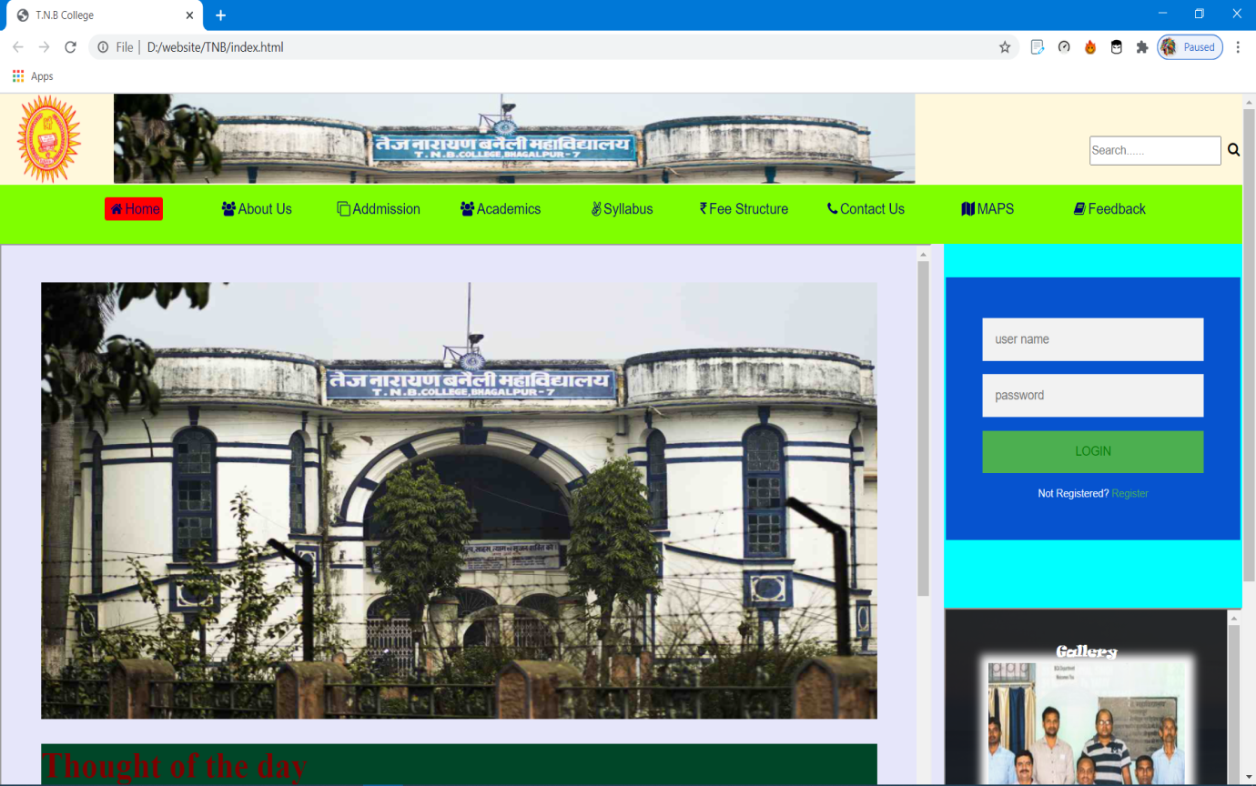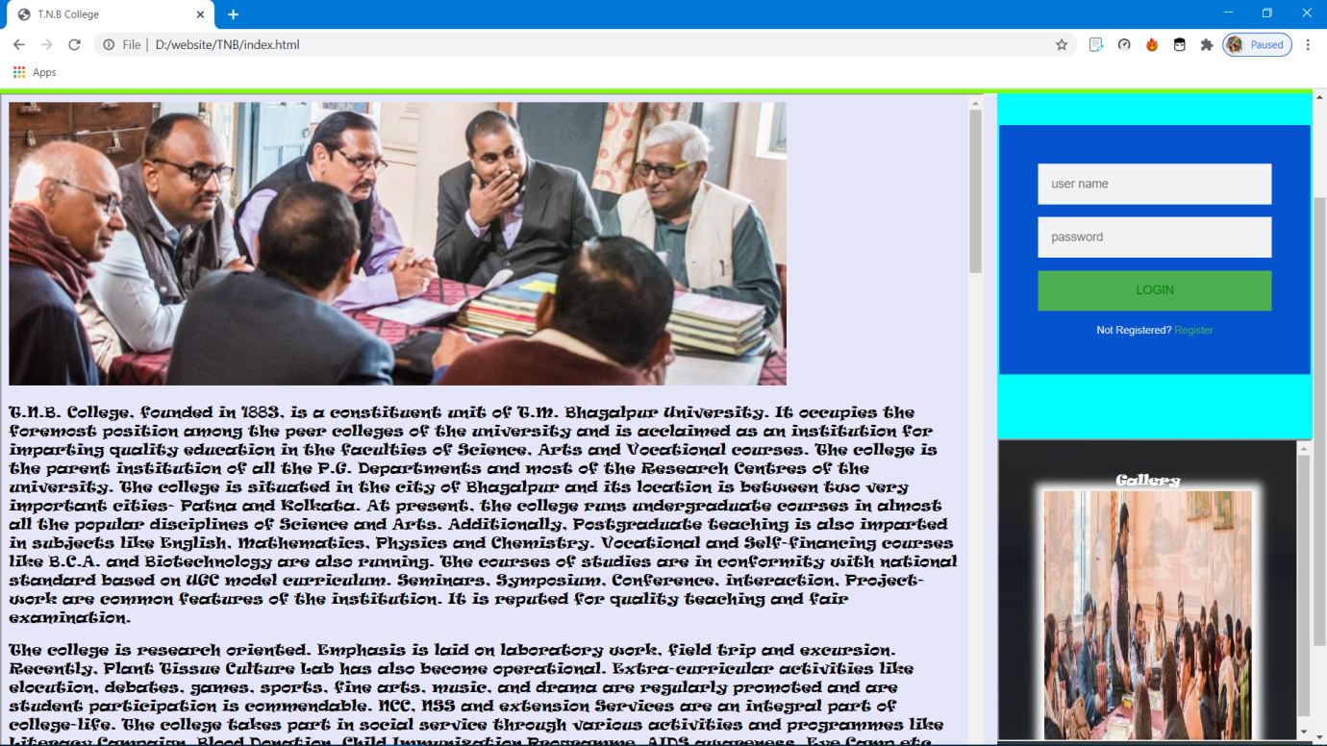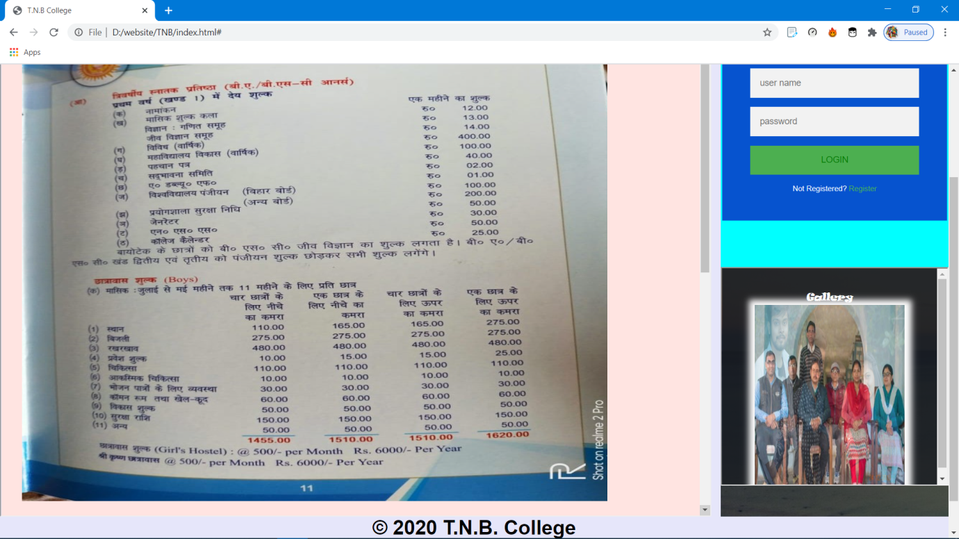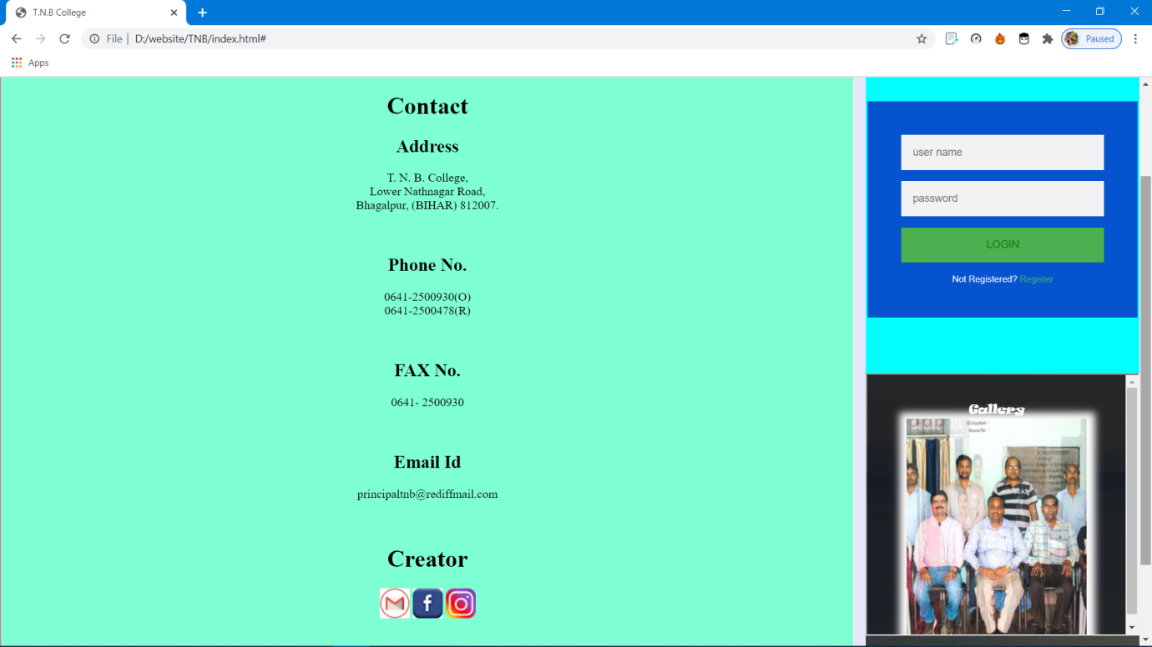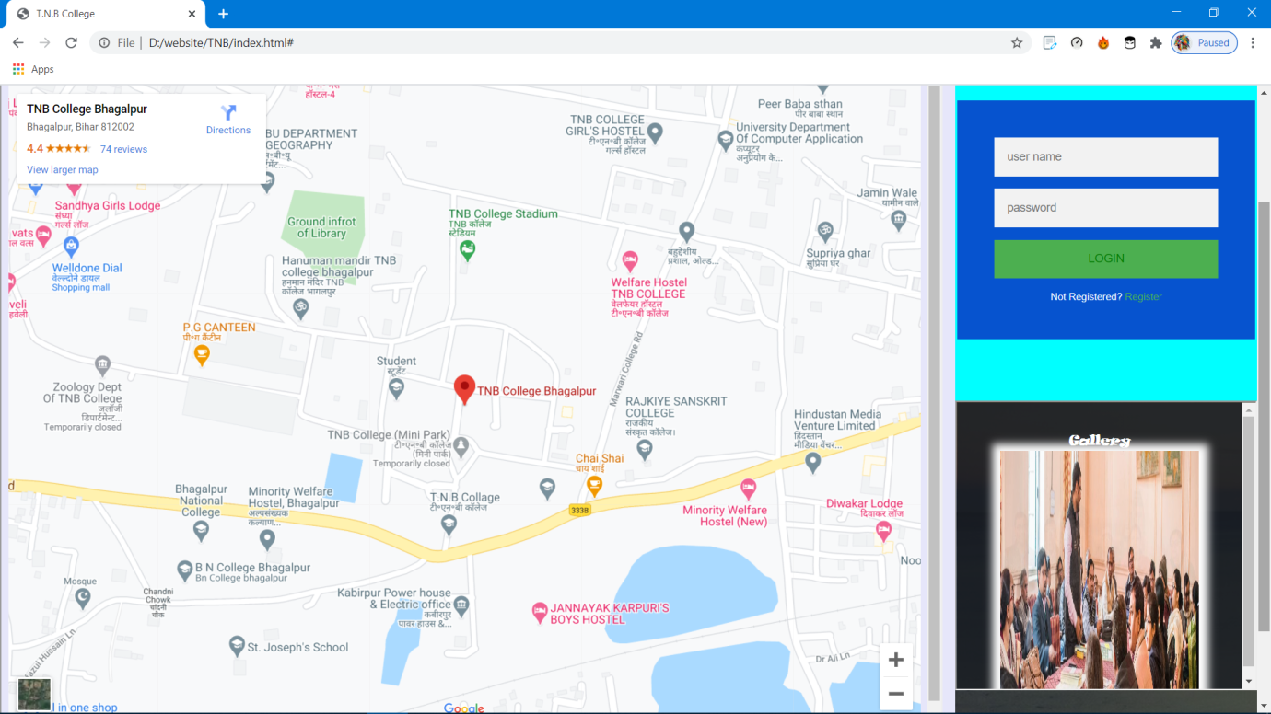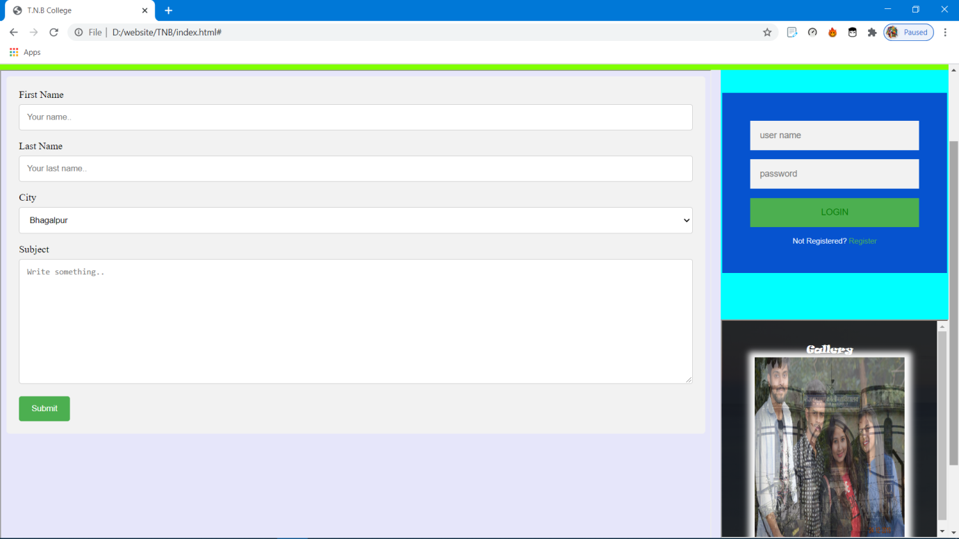

***Conclusion***

*The smart T.N.B. College Management is successfully designed and developed to fulfil the necessary requirements as identified in the requirement analysis phase, such as the system is very much user friendly , form level validation and field level validation are performing very efficiently .*

*The old manual system was suffering form a series of drawbacks. T.N.B. College Management project has been developed on the basis of todays requirement and needs. It is a very easy way to manage the service in best way and provide best service .*

**THE END**